B. In-Depth Explanation & Analysis
1. The Coriolis Force: The Invisible Hand Students struggle with this. It's not a "real" force like gravity; it's an apparent deflection because Earth spins.
- Imagine: You are on a spinning merry-go-round and throw a ball to a friend across it. The ball goes straight, but because you both spun while it was in the air, it looks like it curved away.
- Effect: Winds in Northern Hemisphere deflect to the Right. Winds in Southern Hemisphere deflect to the Left. This is Ferrel's Law.
2. Tropical vs. Extratropical Cyclones
- Tropical Cyclones (e.g., Hurricanes, Typhoons): Violent, compact engines powered by latent heat from warm oceans (must be >27°C). They die quickly over land. Have a calm "eye" in the center.
- Extratropical (Temperate) Cyclones: Large, sprawling systems formed where warm and cold air masses clash (fronts). Can cover entire continents and last for days. No clear "eye".
3. Relative Humidity and "Feeling" Wet
- Absolute Humidity: Grams of water in 1m³ of air.
- Relative Humidity (RH): How "full" the air is. Warmer air can hold MORE water.
- Analogy: A small cup half-full (cold air, 50% RH) vs. a huge bucket half-full (warm air, 50% RH). The bucket has way more actual water, but both are "50% full".
- Key: If you cool air down, its capacity shrinks. Eventually, it hits 100% RH (Dew Point), and excess water must dump out as dew, fog, or rain.
4. Types of Rainfall
- Convectional: Sun heats ground -> air rises rapidly -> afternoon thunderstorm (common at Equator).
- Orographic (Relief): Wind hits a mountain -> forced to rise -> cools and rains on windward side. Leeward side stays dry (Rain Shadow area, e.g., Pune in India).
- Cyclonic/Frontal: Warm air mass forced over cold air mass -> cools and rains.
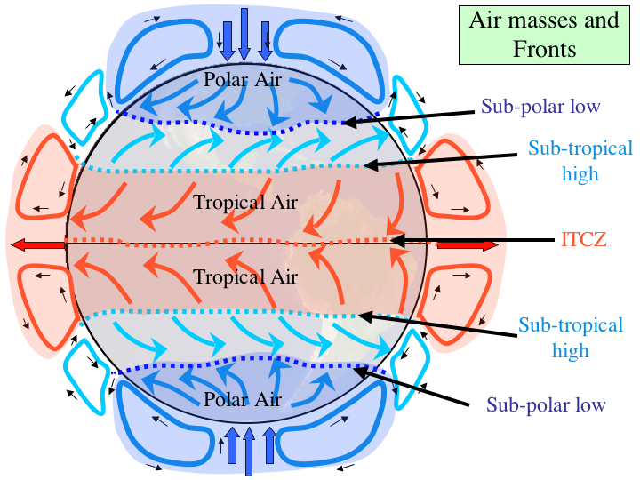
General circulation of the atmosphere
Mentor’s insight:
- Global Pressure Belts - equatorial low, subtropical high, subpolar lows and polar highs. Know seasonal shifts and links to desert/rainfall.
- Pressure-Wind forces trio: pressure gradient (causes motion), Coriolis (deflects: right NH, left SH), Friction (slows surface winds). Explain this with an isobar diagram.
- Three atmospheric cells: trade winds (Hadley), westerlies (Ferrel) and easterlies (polar). To ensure full marks specially in long answer-type questions, make sure to draw the diagrams and label them properly. Use tables to draw comparisons and memorise the standard atmosphere table (sea level: 1013.25).
- Forms of precipitation (rainfall, sleet, snowfall, hail). Forms of condensation (dew, frost, fog and mist, and clouds). You should know how to distinguish between forms precipitation and condensation.
- Types of clouds (cirrus, cumulus, stratus, and nimbus), their appearance and characteristics and height are important to remember.

